Topics in AI

CS 712

Objective: 1) Implement Modified Cross-K Function (Naive Approach).

2) Implement Modified Cross-K Function (Optimised Approach).

**Report By: Instructor:**

Kumar Mangalam Dr. Viswanath Gunturi

Saksham Shrivastava

# Evaluation Results:

*\*a video is recorded to visualize the correctness of algorithm*

## Dataset 1

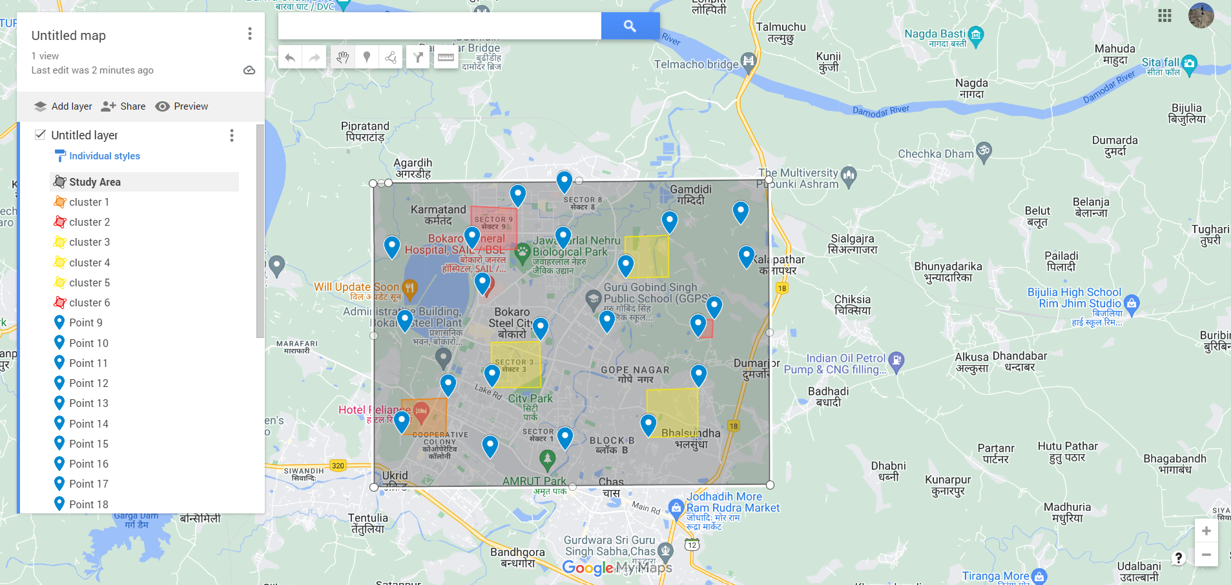

*Dataset 1 was generated using google maps.*

Output of naive approach

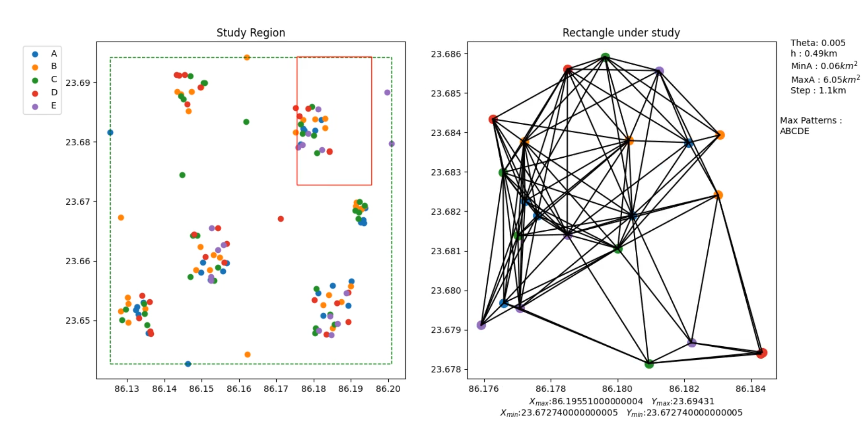

Total execution time for Naive Approach: *10.928 seconds*

Regions Checked : 187

Total Regions : 1813

Output of optimized approach

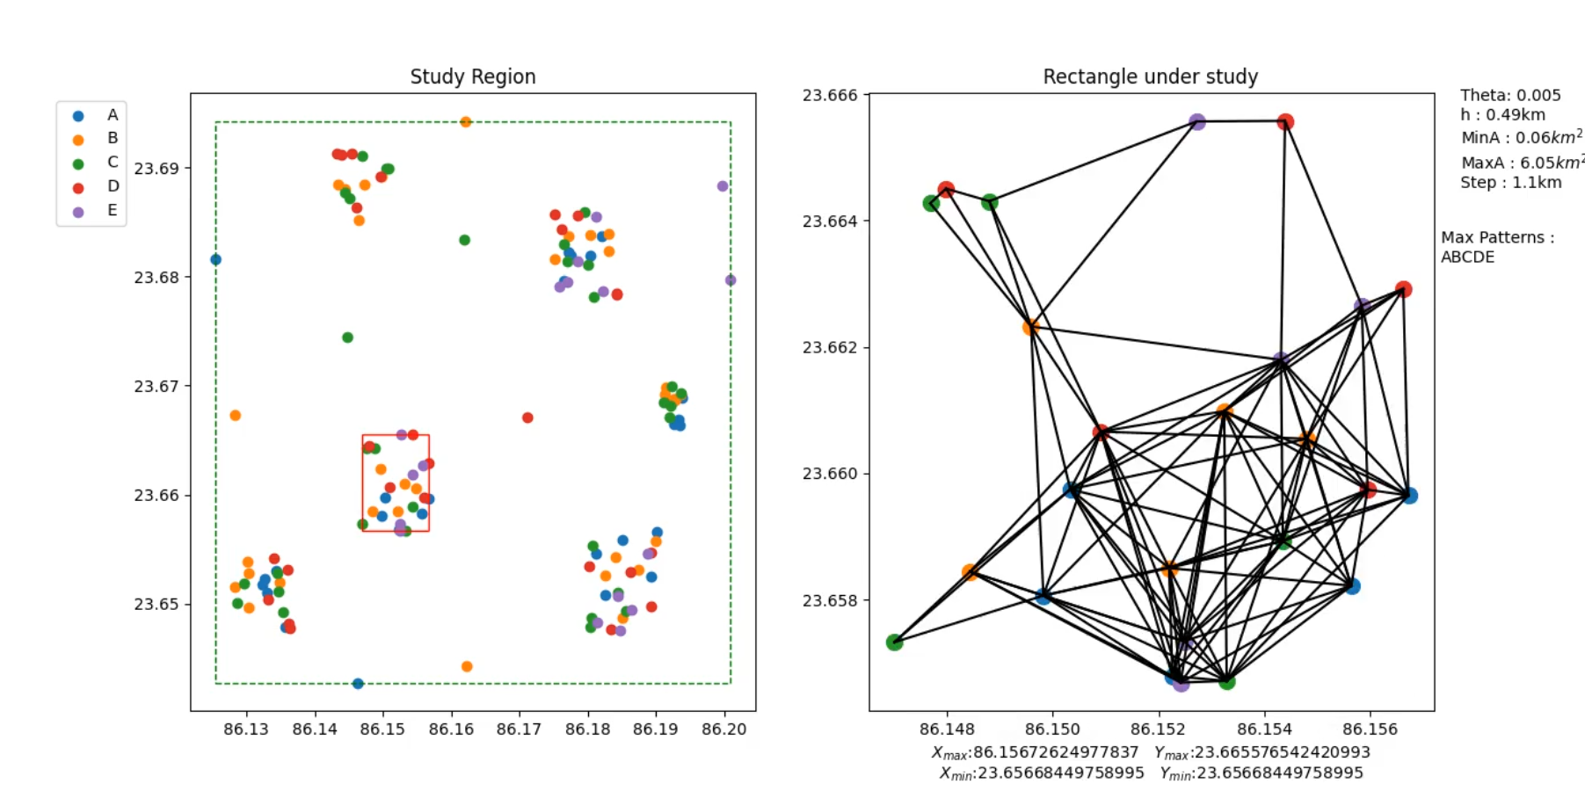

Total execution time for Optimized Approach: *0.658 seconds*

Total clusters found initially: 7

Final clusters left satisfying min. Area condition: 6

## Dataset 2

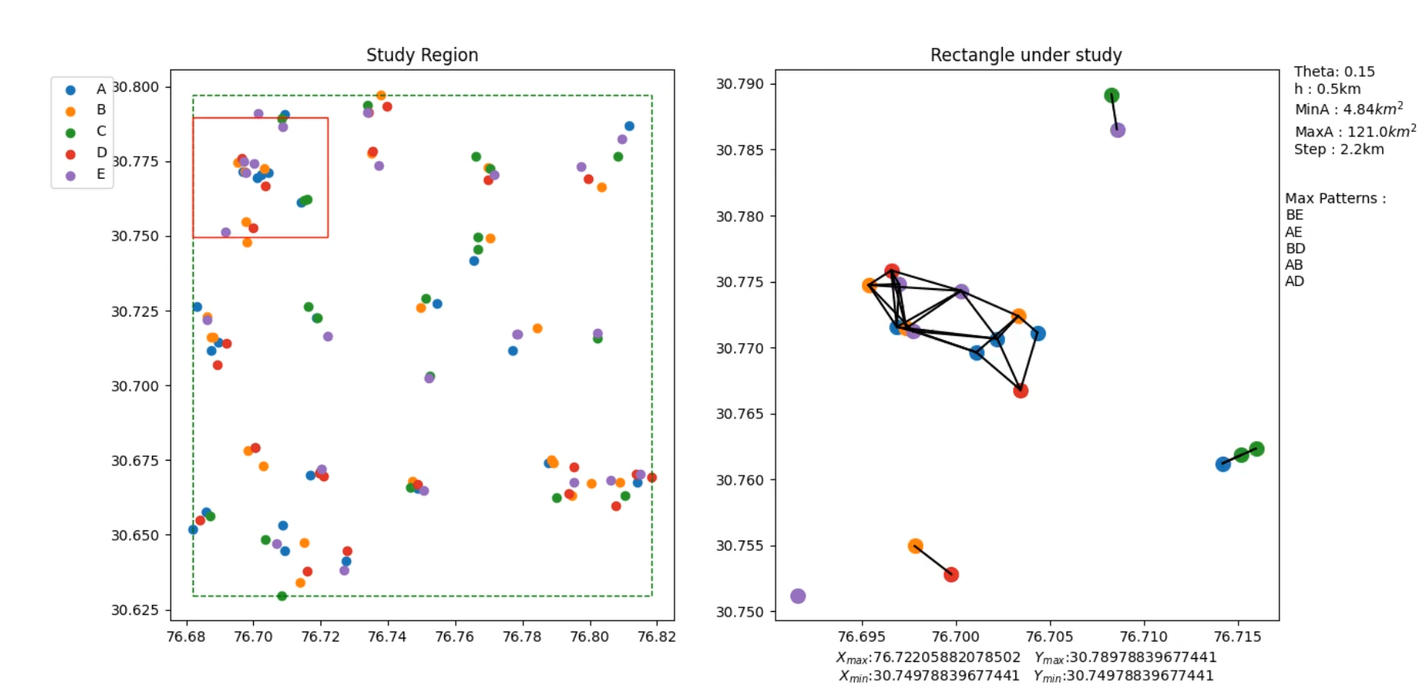

Total execution time for Naive Approach: *23.842 seconds*

Regions Checked : 358

Total Regions : 1980

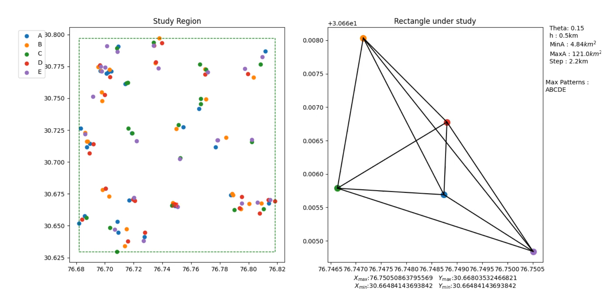

Total execution time for Optimized Approach: *1.417 seconds*

Total clusters found initially: 28

Final clusters left satisfying min. Area condition: 26

*Our optimized approach DBSCAN reduces the time complexity from O(n4) to O(n2).*